**Supplementary material for the article: Dynamics of life expectancy and lifespan equality**

**Authors:** José Manuel Aburtoa,b, Francisco Villavicencioc, Ugofilippo Basellinia, d, Søren Kjærgaarda & James W. Vaupela,b,e

**Author affiliations:**

a Interdisciplinary Centre on Population Dynamics (CPop), University of Southern Denmark, Odense 5000, Denmark

c Department of International Health, Bloomberg School of Public Health, Johns Hopkins University, Baltimore, MD, United States.

b Max Planck Institute for Demographic Research, Rostock 18057, Germany

d Institut national d’études démographiques (INED), F-75020 Paris, France

e Duke University Population Research Institute, Durham, NC 27708, USA

Corresponding authors: José Manuel Aburto & James W. Vaupel

Interdisciplinary Centre on Population Dynamics (CPop), University of Southern Denmark,

Address: J.B. Winsløws Vej 9, Odense C 5000, Denmark.

Telephone: +45 65509416

JMA: [jmaburto@sdu.dk](mailto:jmaburto@sdu.dk)

JWV: [jvaupel@sdu.dk](mailto:jvaupel@sdu.dk)

**Keywords:** Demography, pace & shape, lifespan variation, aging, mortality.

**Classification:** Social sciences – Demography

**A. *Time series Analysis***

**A.1 Finding the order of integration.** Formally, a stochastic process is stationary if, for every collection of time indices 1 ≤ t1 < … < tm, the joint distribution (, , … , ) is the same as the joint distribution of (, , … , ) (1). In loose terms, the properties of the underlying process do not change over time. In contrast, a stochastic process is integrated (i.e. nonstationary) of order *d*, denoted *I(d)*, if it needs to be differenced *d* times to achieve stationarity (2). When *d* equals 1, the process has a unit root. If two variables (e.g. life expectancy and lifespan equality) are integrated and possess a unit root, then shocks are accumulated over time with growing variance, which makes statistical inference problematic (3, 4).

There are two tests to investigate the existence of a unit root for a stochastic process and its order of integration. First, the Kwiatkowski-Phillips-Schmidt-Shin test (KPSS) (5), which tests the null hypothesis of stationarity. Second, the augmented Dickey-Fuller test (ADF) (6), which tests the serial autocorrelation of the process (the null hypothesis is of no autocorrelation).

**Spurious regression.** Refers to the misleading behavior of the conventional correlation coefficient when two variables under study are independent random walks (7), which analyzed with conventional methods could lead to wrong inferences following standard regression procedures (8). For instance, the upward trend of *e*0 and suggests that both variables are non-stationary and could be driven by different random processes. If this was the case, inferences from regression models of *e*0 and would be misleading, including the Pearson correlation coefficient.

In general, regression models for integrated variables could give spurious results. Several ways exist to detect and overcome spurious regressions in order to correctly analyze the relationship between two integrated variables (9). One way to detect a warning signal of spurious regression is if the squared coefficient of determination (*R2*) is greater than the Durbin-Watson statistic (*D-W*) when regressing two variables on each other (8). Figure A.1 shows a scatterplot of the *R2* and the D-W of a linear regression between life expectancy and lifespan equality for each country by sex. In 78.4%[1] of the cases, our results detect a signal of spurious regressions (points in the shaded area).

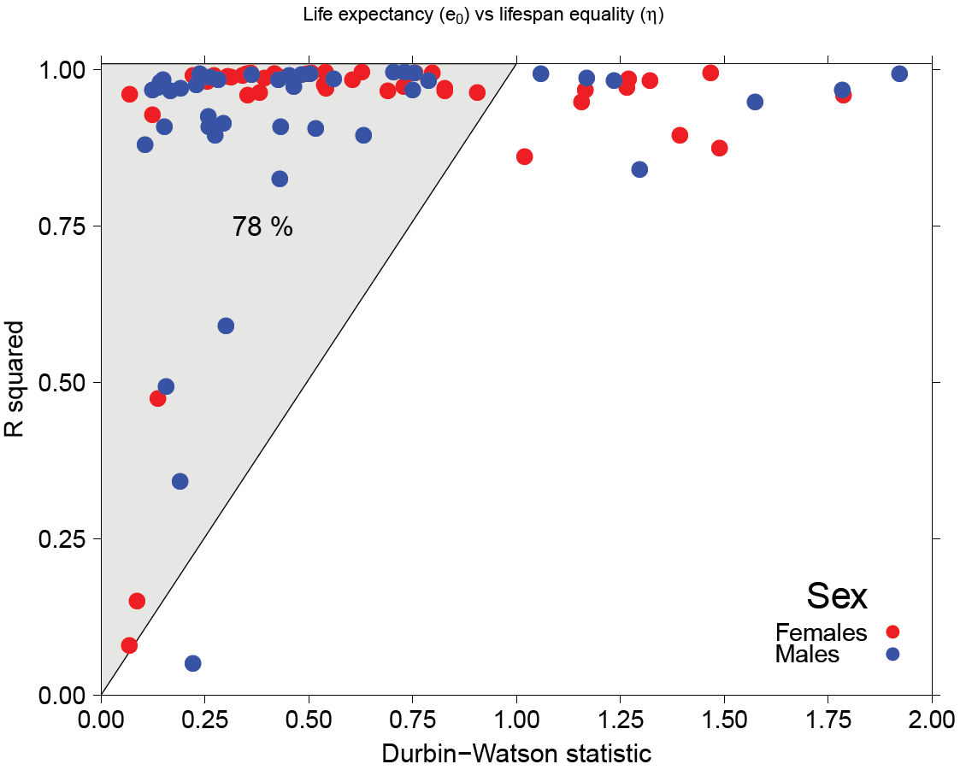**Fig. A.1 Durbin-Watson statistic vs R-squared from regressing life expectancy and lifespan equality**

**Stochastic properties of life expectancy and lifespan equality.** We analyzed the stochastic properties of *e*0 and over time to determine whether they are stationary processes. In the case that they are stationary, we also find the order of integration. We performed the Kwiatkowski–Phillips–Schmidt–Shin test (KPSS) (5) for *e*0 and and the augmented Dickey–Fuller test (ADF) (6) in their levels and first differences, respectively[2]. Using the 95% critical values, the null hypothesis of stationarity can be rejected in 95.6% of the cases for life expectancy, and 97.8% for lifespan equality ()[3], see SI Appendix Fig. 3A. Moreover, at the same level, the null-hypothesis of a unit-root in their first differences is rejected uniformly for life expectancy and almost 98% for lifespan equality[4], see SI Appendix Fig. 3B; these analyses thus suggest that the variables are nonstationary processes and achieve stationarity after differencing once for both females and males. For the remainder of the study, we treat both variables as integrated of order one, *I(1)*.

**Fig. A.2** KPSS and ADF tests for and . Calculations based on data from HMD (1).

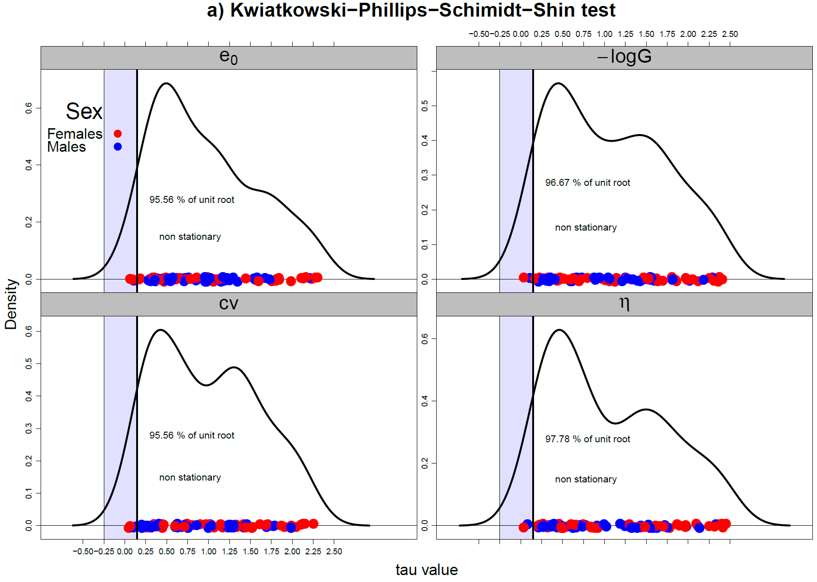

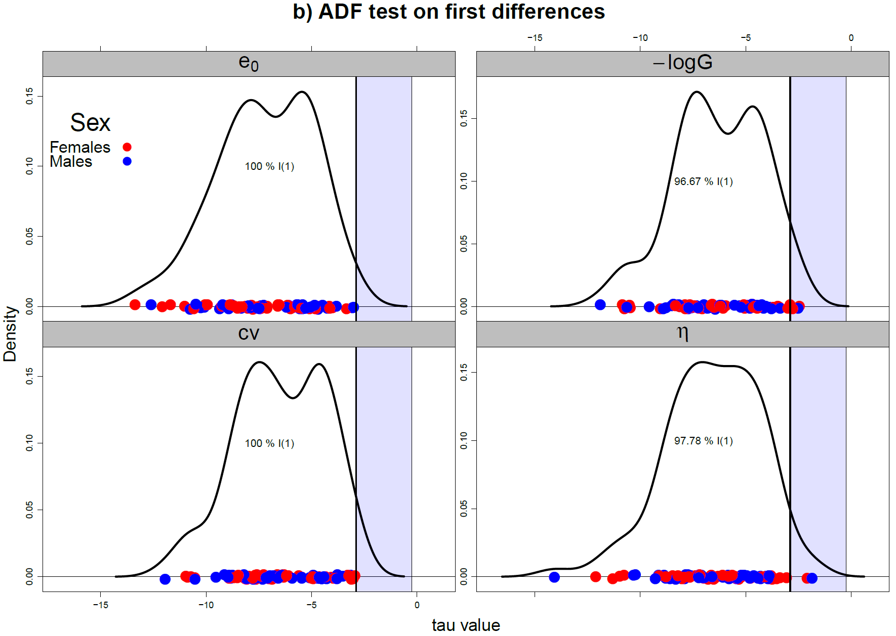

**A.2 Cointegration.** The concept of cointegration was developed to avoid misleading interpretations regarding the relationship between two integrated variables (10). It refers to the case of a model that can adjust for stochastic trends to produce stationary residuals, and it allows detecting stable long-run relationships among integrated variables.

Formally, two cointegrated variables can be expressed using a 2-dimensional vector autoregressive model in its equilibrium correction (VECM) form:

Where is the first difference operator, is a *2x1* vector of stochastic variables, life expectancy and lifespan equality in our case; and are *2x1* vectors of full rank, is a vector of constants and is a vector of normally, independently, and identically distributed errors with zero means and constant variances. We specify the model with an unrestricted constant in the cointegration space and dummy variables in contexts where life expectancy experienced historical shocks, such as World Wars and epidemics (see SI Appendix table 2). This is known as a case 4 model (3) and deals correctly with the deterministic components of the observed behavior of life expectancy and lifespan equality (11-13). An advantage of this framework is that, under cointegration, parameter estimates are super consistent, which make them robust to omitted variables and endogeneity related issues (4).

We use the optimal lag length based on the Akaike Information Criterion (AIC). We applied four information criteria to 264 time series (see SI Appendix table 3) (14-17). In all of them, the most selected lags are one and two as optimal. We decided to choose AIC in our time series analysis based on the accuracy of the method (18) to avoid over-parametrization and to have consistency across countries and sexes.

There are two test statistics for cointegration, the Lambda-max and the trace statistics (19). The first one tests the null hypothesis of *r* cointegrating vectors against the specific alternative of *r+1* cointegrating vector(s). The trace statistic tests the null hypothesis of no cointegrating vector against a general alternative of one or more cointegrating vectors (*r>1*). We performed both tests to each country for females and males separately.

Subsequently, after finding *r* cointegrating relationships, we estimated the VECM representation of each system, that is, we ran an OLS regression on the lagged differenced variables and the error correction term derived from the previous step. All the analyses were carried out using the programming language R (20).

**Granger causality.** The notion of Granger causality refers to a probabilistic concept of causality that exploits the fact that causes must precede their effects in time (21, 22). Although temporal precedence alone is not enough to stablish a causal link, the concept of Granger causality still remains useful for causal learning when taking into account its limitations (23).

We performed instantaneous causality tests for all the populations in our study and found that in 90% of the cases the null hypothesis of no instantaneous causality was rejected. Moreover, 84% of the cases exhibit a negative error correction coefficient, which is significant in more than 60% of cases. These findings confirm that a long-run co-movement exists between life expectancy and lifespan equality. It is worth mentioning that we did not find clear patterns or cuts in the speed of adjustment and in the cointegrating vector, other than similar directions for most countries.

**A.3 Exceptions for long-run evidence.**

Some countries did not show evidence of a long-run relationship: females in Lithuania, Belarus and New Zealand, and males in Lithuania, Belarus and Belgium. This could be a result of data quality and short time series. For instance, data quality has long been an issue in countries from Eastern Europe, such as Lithuania and Belarus, during the Soviet Period (24). Similarly, New Zealand has been subject to compositional effects due to the changes in proportions of the Maori and European populations (24). Finally, Belgium was only considered for the years after 1950 because data series for the period 1914-1918 are inexistent and the geographical composition has changed substantially since the 19th century (24).

**Section B. Time derivatives of and**

**Proposition 1.** *Let Then, its partial derivative with respect to time can be expressed as*

|  |  |
| --- | --- |
|  | [B1] |

*where*

|  |  |
| --- | --- |
|  |  |

*Proof.* Applying the chain rule, the derivative with respect to time of is simply

|  |  |
| --- | --- |
|  |  |

Using that , and reversing the order of integration, we get

|  |  |
| --- | --- |
|  |  |

which proves Eq. B1.

**Proposition 2.** *Let where and The, its partial derivative with respect to time can be expressed as*

|  |  |
| --- | --- |
|  | [B2] |

*with*

|  |  |
| --- | --- |
|  |  |

*wnd*

*Proof.* From Eq. (2) and (10), we have that

|  |  |
| --- | --- |
|  | [B3] |

And

|  |  |
| --- | --- |
|  | [B4] |

Replacing Eq. (B1) and Eq. (B3) in Eq. (B4) yields

|  |  |
| --- | --- |
|  |  |

which proves Eq. (B2).

**Section C. Time derivatives of and**

**Proposition 3.** *Let*

|  |  |
| --- | --- |
|  |  |

*be the standard deviation of the lifetable age-at-death distribution. Then, its partial derivative with respect to time can be expressed as*

|  |  |
| --- | --- |
|  | [B5] |

*Proof.* Following Gillespie et al. (2014) (25), the time derivative of the variance of the age-at-death distribution is

|  |  |
| --- | --- |
|  |  |

Applying the chain rule, the time derivative of is given by

|  |  |
| --- | --- |
|  | [B6] |

Which proves Eq. B5.

**Proposition 4.** *Let , where is the life expectancy at birth and*

|  |  |
| --- | --- |
|  |  |

*be the standard deviation of the lifetable age-at-death distribution. Then, the partial derivative of with respect to time can be expressed as*

|  |  |
| --- | --- |
|  | [B7] |

*where*

|  |  |
| --- | --- |
|  |  |

*and*

|  |  |
| --- | --- |
|  |  |

*Proof.* Following the definition of , its time derivative can be expressed as

|  |  |
| --- | --- |
|  | [B8] |

Replacing Eq. 2 in the main manuscript and Eq. (B6) in (B8), we get

|  |  |
| --- | --- |
|  |  |

Which proves Eq. B7.

**Fig. S1** Association between changes in life expectancy and changes in lifespan equality (10-year lag), and . Calculations based on data from HMD (1).

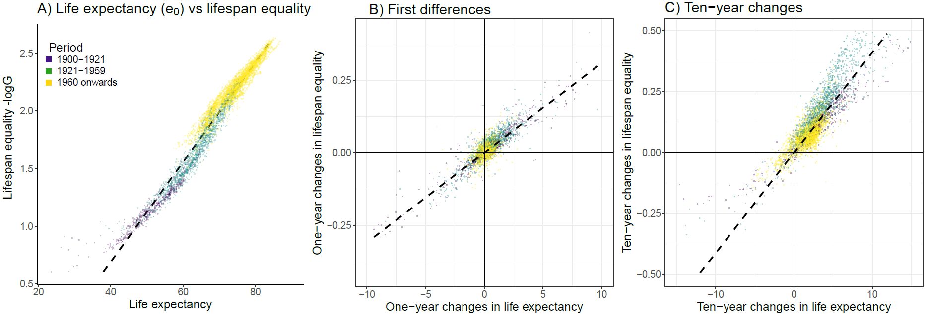

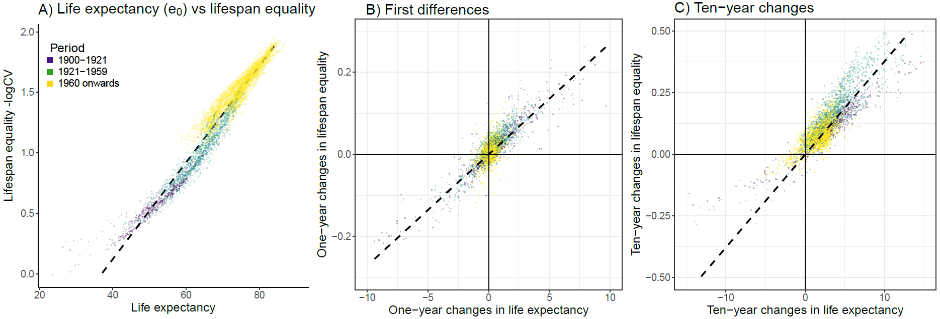

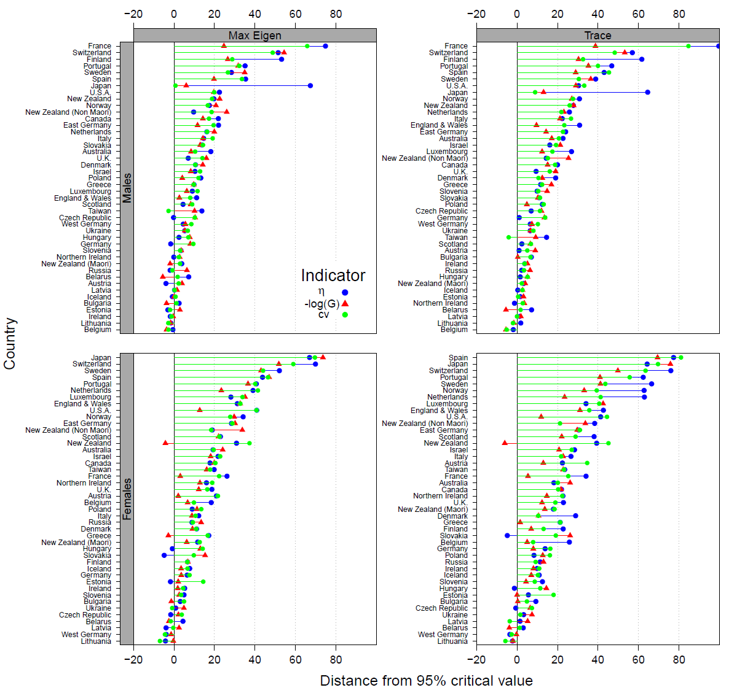**Fig. S2** Johansen Trace and Lambda Max Cointegrations tests for with and . Calculations based on data from HMD (1). Since we are interested in whether *e*0 andhave a long-run relationship, we focus on the rejection of the null hypothesis of no long-run equilibrium. Each point indicates deviation from the 5% significance critical value. Positive values indicate a long-run relationship, while negative show no evidence to reject the null hypothesis of no long-run relationship.

**Fig. S3 Standardized weights for the changes in lifespan equality .**

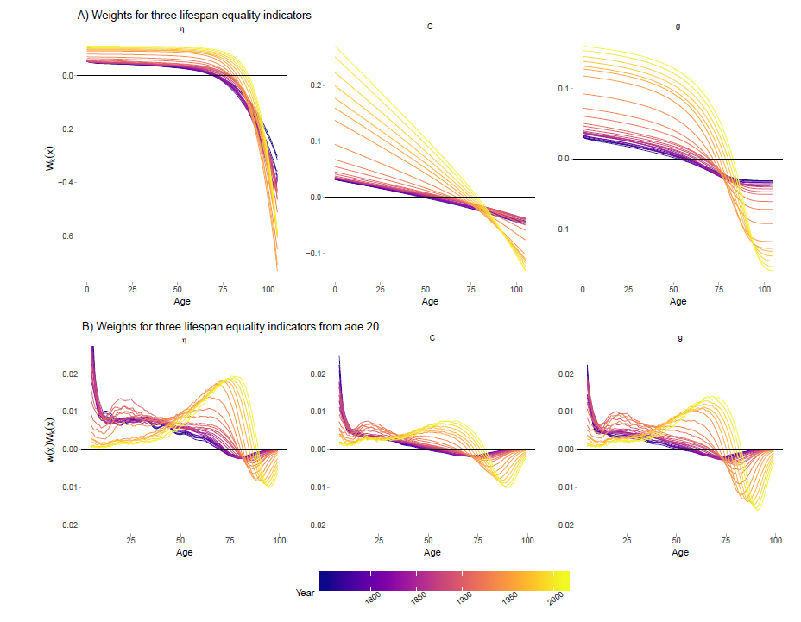

**Fig. S4** Association between changes in life expectancy and lifespan equality ( and ) below and above the threshold age. Dotted lines show the directions of the relationship below and above the threshold age. Calculations based on data from HMD (1).

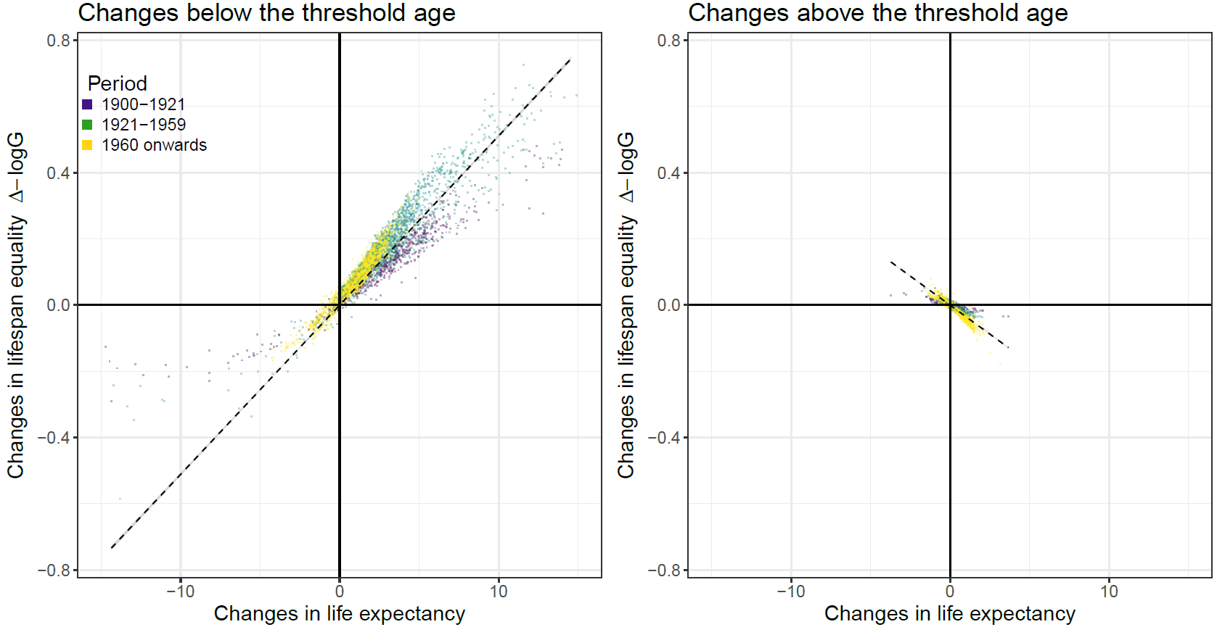

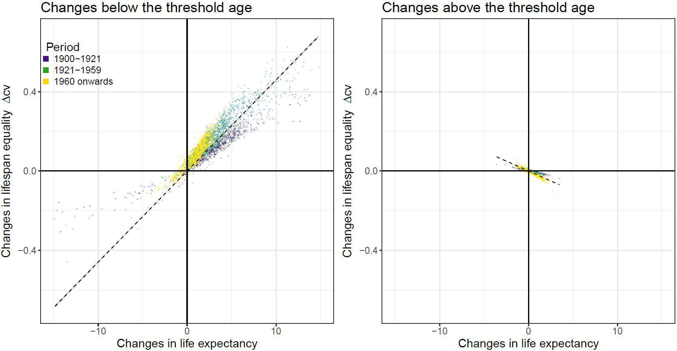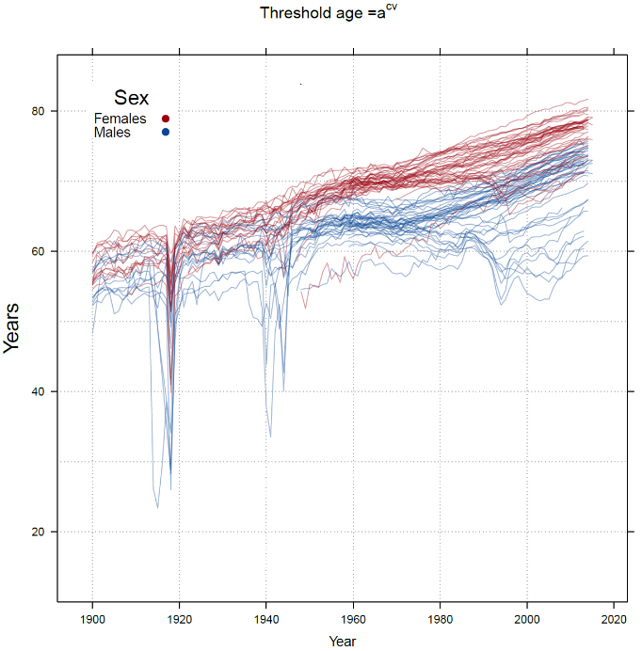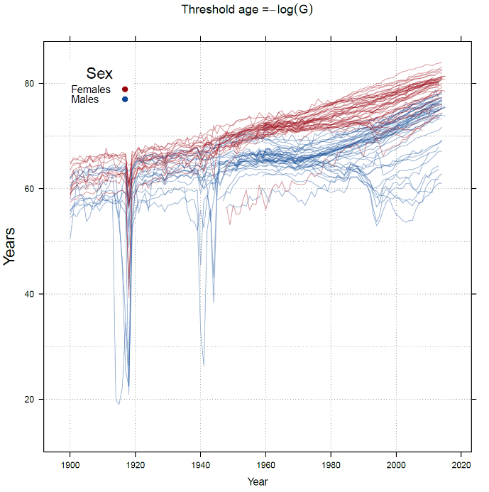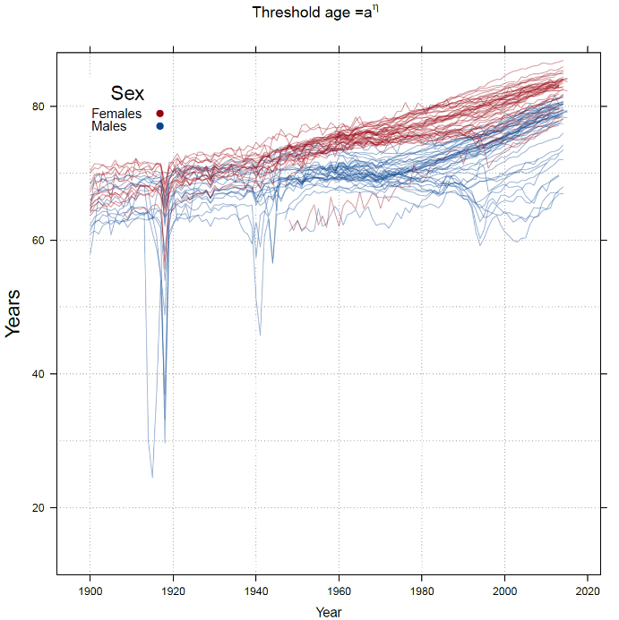**Fig. S5** Threshold age trajectories for and . Calculations based on data from HMD (1).

**Table S1** Females. Countries and regions in the Human Mortality Database used in our study, ranked by female life expectancy for the newest year available.

|  |  |  |  |  |  |  |  |  |  |  |
| --- | --- | --- | --- | --- | --- | --- | --- | --- | --- | --- |
| No | Country | Initial | Final | e0 |  | l | cv | a | a-logG | acv |
| 1 | Japan | 1947 | 2014 | 86.84 | 2.13 | 2.61 | 1.90 | 86.83 | 84.05 | 81.69 |
| 2 | Spain | 1908 | 2014 | 85.61 | 2.15 | 2.63 | 1.93 | 85.33 | 82.69 | 80.54 |
| 3 | France | 1900 | 2014 | 85.40 | 2.09 | 2.54 | 1.84 | 85.88 | 83.08 | 80.35 |
| 4 | Switzerland | 1900 | 2014 | 85.10 | 2.16 | 2.63 | 1.91 | 85.14 | 82.51 | 80.15 |
| 5 | Australia | 1921 | 2014 | 84.59 | 2.10 | 2.56 | 1.85 | 84.84 | 81.97 | 79.51 |
| 6 | Luxembourg | 1960 | 2014 | 84.48 | 2.09 | 2.56 | 1.87 | 84.34 | 81.34 | 79.21 |
| 7 | Italy | 1900 | 2012 | 84.45 | 2.14 | 2.61 | 1.91 | 84.26 | 81.52 | 79.34 |
| 8 | Finland | 1900 | 2015 | 84.19 | 2.14 | 2.60 | 1.92 | 84.18 | 81.41 | 79.04 |
| 9 | Norway | 1900 | 2014 | 84.09 | 2.11 | 2.59 | 1.91 | 83.99 | 81.06 | 78.75 |
| 10 | Israel | 1983 | 2014 | 84.08 | 2.10 | 2.58 | 1.88 | 83.77 | 80.83 | 78.81 |
| 11 | Sweden | 1900 | 2014 | 84.05 | 2.12 | 2.59 | 1.91 | 84.04 | 81.13 | 78.79 |
| 12 | Portugal | 1940 | 2015 | 84.02 | 2.16 | 2.63 | 1.92 | 83.99 | 81.37 | 79.11 |
| 13 | Austria | 1947 | 2014 | 83.72 | 2.10 | 2.56 | 1.86 | 84.07 | 81.24 | 78.67 |
| 14 | Canada | 1921 | 2011 | 83.69 | 2.01 | 2.47 | 1.78 | 84.10 | 80.82 | 78.36 |
| 15 | Greece | 1981 | 2013 | 83.67 | 2.11 | 2.60 | 1.89 | 83.14 | 80.59 | 78.60 |
| 16 | Slovenia | 1983 | 2014 | 83.66 | 2.13 | 2.61 | 1.92 | 83.49 | 80.74 | 78.46 |
| 17 | Iceland | 1900 | 2013 | 83.46 | 2.09 | 2.57 | 1.89 | 83.14 | 80.10 | 78.06 |
| 18 | New Zealand | 1948 | 2013 | 83.42 | 2.04 | 2.50 | 1.79 | 83.88 | 80.83 | 78.31 |
| 19 | Ireland | 1950 | 2014 | 83.21 | 2.05 | 2.53 | 1.84 | 82.95 | 80.03 | 77.89 |
| 20 | Belgium | 1919 | 2015 | 83.15 | 2.07 | 2.52 | 1.83 | 83.65 | 80.69 | 78.02 |
| 21 | NZ non-Maori | 1901 | 2008 | 83.06 | 2.06 | 2.52 | 1.81 | 83.31 | 80.31 | 77.98 |
| 22 | England & Wales | 1900 | 2013 | 82.97 | 2.04 | 2.51 | 1.82 | 83.05 | 79.93 | 77.62 |
| 23 | West Germany | 1956 | 2013 | 82.87 | 2.09 | 2.55 | 1.85 | 83.08 | 80.24 | 77.73 |
| 24 | Germany | 1990 | 2013 | 82.86 | 2.09 | 2.55 | 1.86 | 83.03 | 80.19 | 77.72 |
| 25 | Taiwan | 1970 | 2014 | 82.83 | 1.99 | 2.47 | 1.79 | 82.75 | 79.53 | 77.40 |
| 26 | East Germany | 1956 | 2013 | 82.82 | 2.09 | 2.56 | 1.87 | 82.85 | 80.03 | 77.67 |
| 27 | Netherlands | 1900 | 2012 | 82.82 | 2.06 | 2.52 | 1.84 | 83.09 | 80.07 | 77.56 |
| 28 | UKR | 1922 | 2013 | 82.78 | 2.03 | 2.50 | 1.81 | 82.87 | 79.70 | 77.40 |
| 29 | Denmark | 1900 | 2014 | 82.67 | 2.02 | 2.50 | 1.83 | 82.55 | 79.23 | 77.05 |
| 30 | Northern Ireland | 1922 | 2013 | 82.25 | 2.02 | 2.48 | 1.80 | 82.36 | 79.15 | 76.88 |
| 31 | Czech Republic | 1950 | 2014 | 81.72 | 2.08 | 2.54 | 1.87 | 81.66 | 78.66 | 76.39 |
| 32 | Polonia | 1958 | 2014 | 81.41 | 1.98 | 2.44 | 1.77 | 81.76 | 78.45 | 75.98 |
| 33 | USA | 1933 | 2015 | 81.35 | 1.87 | 2.33 | 1.65 | 82.33 | 78.57 | 75.92 |
| 34 | Estonia | 1959 | 2013 | 81.33 | 2.00 | 2.45 | 1.77 | 81.83 | 78.62 | 76.10 |
| 35 | Scotland | 1900 | 2013 | 81.07 | 1.96 | 2.43 | 1.77 | 81.18 | 77.75 | 75.49 |
| 36 | Chile | 1992 | 2005 | 80.74 | 1.87 | 2.36 | 1.67 | 80.70 | 77.27 | 75.34 |
| 37 | Slovakia | 1950 | 2014 | 80.32 | 1.99 | 2.46 | 1.76 | 80.30 | 77.25 | 75.11 |
| 38 | Lithuania | 1959 | 2013 | 79.37 | 1.92 | 2.35 | 1.68 | 80.39 | 77.11 | 74.17 |
| 39 | Hungary | 1950 | 2014 | 79.24 | 1.93 | 2.40 | 1.74 | 79.45 | 76.01 | 73.58 |
| 40 | Latvia | 1959 | 2013 | 78.73 | 1.90 | 2.34 | 1.67 | 79.62 | 76.09 | 73.38 |
| 41 | Belarus | 1959 | 2014 | 78.43 | 1.91 | 2.37 | 1.71 | 78.70 | 75.36 | 72.98 |
| 42 | Bulgaria | 1947 | 2010 | 77.25 | 1.93 | 2.35 | 1.64 | 78.14 | 75.09 | 72.66 |
| 43 | Russia | 1959 | 2014 | 76.48 | 1.79 | 2.21 | 1.54 | 78.07 | 74.41 | 71.48 |
| 44 | Ukraine | 1959 | 2013 | 76.21 | 1.82 | 2.27 | 1.59 | 77.11 | 73.58 | 71.14 |
| 45 | NZ Maori | 1948 | 2008 | 75.64 | 1.72 | 2.21 | 1.57 | 75.95 | 71.02 | 69.34 |

**Males**

|  |  |  |  |  |  |  |  |  |  |  |
| --- | --- | --- | --- | --- | --- | --- | --- | --- | --- | --- |
| No | Country | Initial | Final | e0 |  | l | cv | a | a-logG | acv |
| 1 | Switzerland | 1900 | 2014 | 80.92 | 2.00 | 2.45 | 1.77 | 81.45 | 78.23 | 75.69 |
| 2 | Australia | 1921 | 2014 | 80.64 | 1.94 | 2.39 | 1.71 | 81.30 | 77.95 | 75.35 |
| 3 | Japan | 1947 | 2014 | 80.51 | 1.94 | 2.41 | 1.75 | 80.72 | 77.28 | 74.92 |
| 4 | Iceland | 1900 | 2013 | 80.39 | 2.01 | 2.48 | 1.81 | 80.31 | 77.33 | 75.07 |
| 5 | Israel | 1983 | 2014 | 80.37 | 1.91 | 2.39 | 1.72 | 80.35 | 76.82 | 74.74 |
| 6 | Sweden | 1900 | 2014 | 80.35 | 2.00 | 2.45 | 1.78 | 80.62 | 77.39 | 75.04 |
| 7 | Spain | 1908 | 2014 | 80.09 | 1.93 | 2.40 | 1.75 | 80.33 | 76.68 | 74.33 |
| 8 | Norway | 1900 | 2014 | 80.02 | 1.99 | 2.44 | 1.76 | 80.35 | 77.03 | 74.69 |
| 9 | New Zealand | 1948 | 2013 | 79.80 | 1.91 | 2.36 | 1.67 | 80.41 | 77.06 | 74.63 |
| 10 | Italy | 1900 | 2012 | 79.72 | 1.97 | 2.43 | 1.76 | 79.83 | 76.56 | 74.29 |
| 11 | Canada | 1921 | 2011 | 79.52 | 1.89 | 2.34 | 1.66 | 80.23 | 76.60 | 74.18 |
| 12 | France | 1900 | 2014 | 79.26 | 1.85 | 2.30 | 1.64 | 80.60 | 76.68 | 73.64 |
| 13 | England & Wales | 1900 | 2013 | 79.23 | 1.91 | 2.37 | 1.70 | 79.71 | 76.20 | 73.81 |
| 14 | Ireland | 1950 | 2014 | 79.16 | 1.91 | 2.37 | 1.69 | 79.43 | 76.16 | 73.84 |
| 15 | Netherlands | 1900 | 2012 | 79.14 | 1.97 | 2.43 | 1.76 | 79.20 | 75.93 | 73.79 |
| 16 | Luxembourg | 1960 | 2014 | 79.12 | 1.96 | 2.40 | 1.74 | 79.77 | 76.06 | 73.53 |
| 17 | NZ non-Maori | 1901 | 2008 | 79.05 | 1.89 | 2.35 | 1.66 | 79.44 | 76.21 | 74.00 |
| 18 | UK | 1922 | 2013 | 79.01 | 1.90 | 2.36 | 1.69 | 79.51 | 75.97 | 73.57 |
| 19 | Austria | 1947 | 2014 | 78.91 | 1.91 | 2.36 | 1.71 | 79.57 | 75.85 | 73.26 |
| 20 | Finland | 1900 | 2015 | 78.62 | 1.91 | 2.35 | 1.71 | 79.34 | 75.56 | 72.94 |
| 21 | Belgium | 1919 | 2015 | 78.56 | 1.91 | 2.35 | 1.70 | 79.23 | 75.47 | 72.99 |
| 22 | Denmark | 1900 | 2014 | 78.56 | 1.91 | 2.37 | 1.71 | 79.03 | 75.35 | 72.96 |
| 23 | Greece | 1981 | 2013 | 78.44 | 1.82 | 2.30 | 1.65 | 78.89 | 75.10 | 72.65 |
| 24 | West Germany | 1956 | 2013 | 78.22 | 1.91 | 2.37 | 1.71 | 78.68 | 75.02 | 72.60 |
| 25 | Northern Ireland | 1922 | 2013 | 78.10 | 1.87 | 2.32 | 1.64 | 78.99 | 75.41 | 72.84 |
| 26 | Portugal | 1940 | 2015 | 78.02 | 1.89 | 2.33 | 1.68 | 79.11 | 75.38 | 72.56 |
| 27 | Germany | 1990 | 2013 | 77.99 | 1.90 | 2.35 | 1.70 | 78.50 | 74.80 | 72.34 |
| 28 | Slovenia | 1983 | 2014 | 77.95 | 1.89 | 2.36 | 1.73 | 78.19 | 74.41 | 72.05 |
| 29 | Scotland | 1900 | 2013 | 77.04 | 1.82 | 2.28 | 1.63 | 77.67 | 73.84 | 71.39 |
| 30 | East Germany | 1956 | 2013 | 76.98 | 1.85 | 2.31 | 1.67 | 77.73 | 73.87 | 71.22 |
| 31 | Taiwan | 1970 | 2014 | 76.55 | 1.72 | 2.19 | 1.55 | 77.40 | 73.26 | 70.74 |
| 32 | USA | 1933 | 2015 | 76.50 | 1.70 | 2.14 | 1.49 | 78.27 | 73.83 | 71.06 |
| 33 | Czech Republic | 1950 | 2014 | 75.71 | 1.84 | 2.30 | 1.66 | 75.93 | 71.70 | 69.72 |
| 34 | Chile | 1992 | 2005 | 74.99 | 1.63 | 2.13 | 1.47 | 75.34 | 71.25 | 69.46 |
| 35 | Poland | 1958 | 2014 | 73.66 | 1.68 | 2.15 | 1.53 | 74.15 | 69.26 | 67.42 |
| 36 | Slovakia | 1950 | 2014 | 73.25 | 1.72 | 2.19 | 1.55 | 73.43 | 69.07 | 67.29 |
| 37 | Estonia | 1959 | 2013 | 72.72 | 1.67 | 2.15 | 1.54 | 72.78 | 67.97 | 66.32 |
| 38 | NZ Maori | 1948 | 2008 | 72.51 | 1.49 | 2.07 | 1.44 | 72.10 | 67.54 | 66.19 |
| 39 | Hungary | 1950 | 2014 | 72.26 | 1.69 | 2.18 | 1.56 | 72.01 | 67.11 | 65.76 |
| 40 | Bulgaria | 1947 | 2010 | 70.31 | 1.65 | 2.09 | 1.44 | 71.47 | 66.75 | 64.91 |
| 41 | Latvia | 1959 | 2013 | 69.26 | 1.56 | 2.03 | 1.43 | 69.68 | 64.30 | 62.87 |
| 42 | Lithuania | 1959 | 2013 | 68.52 | 1.51 | 1.97 | 1.38 | 69.55 | 63.71 | 62.12 |
| 43 | Belarus | 1959 | 2014 | 67.81 | 1.54 | 2.03 | 1.43 | 67.90 | 62.84 | 61.45 |
| 44 | Ukraine | 1959 | 2013 | 66.31 | 1.47 | 1.94 | 1.33 | 67.16 | 61.84 | 60.34 |
| 45 | Russia | 1959 | 2014 | 65.26 | 1.38 | 1.85 | 1.26 | 66.94 | 61.06 | 59.37 |

**Table S2** Years in which dummy variables were added. The dummy variables account for the following historic events: 1918 the Spanish flu, 1914 - 1919 World War 1, 1940 - 1945 World War 2 (1939 included for Spain to account for the Spanish civil war) and 1992 - 1995 dissolution of the Soviet Union.

|  |  |  |
| --- | --- | --- |
| **Country** | **Data years** | **Dummy Years** |
| Australia | 1921 - 2011 | Non |
| Austria | 1947 - 2014 | Non |
| Belgium | 1920 - 2013 | 1940 - 1945 |
| Bulgaria | 1947 - 2010 | Non |
| Belarus | 1959 - 2014 | 1992 - 1995 |
| Canada | 1921 - 2011 | Non |
| Czech Republic | 1950 - 2014 | Non |
| Denmark | 1900 - 2014 | 1918 and 1940 - 1945 |
| Estonia | 1959 - 2014 | 1992 - 1995 |
| Finland | 1900 - 2012 | 1918 and 1940 - 1945 |
| France | 1900 - 2014 | 1914 - 1919 and 1940 -1945 |
| Germany | 1990 - 2013 | Non |
| Greece | 1981 - 2013 | Non |
| Hungary | 1950 - 2014 | 1992 - 1995 |
| Iceland | 1900 - 2013 | Non |
| Ireland | 1950 - 2014 | Non |
| Israel | 1983 - 2014 | Non |
| Italy | 1900 - 2012 | 1914 - 1919 and 1940 - 1945 |
| East Germany | 1956 - 2013 | 1992 - 1995 |
| West Germany | 1956 - 2013 | Non |
| Japan | 1947 - 2012 | Non |
| Latvia | 1959 - 2013 | 1992 - 1995 |
| Lithuania | 1959 - 2013 | 1992 - 1995 |
| Luxembourg | 1960 - 2014 | Non |
| Netherlands | 1900 - 2013 | 1918 and 1940 - 1945 |
| New Zealand Maori | 1948 - 2008 | 1918 |
| New Zealand Non-Maori | 1948 - 2008 | 1918 |
| Norway | 1900 - 2014 | 1918 and 1940 - 1945 |
| Northern Ireland | 1922 - 2013 | 1940 - 1945 |
| Poland | 1958 - 2014 | 1992 - 1995 |
| Portugal | 1940 - 2012 | Non |
| Russia | 1959 - 2014 | 1992 - 1995 |
| Scotland | 1900 - 2013 | Non |
| Slovakia | 1950 - 2014 | Non |
| Slovenia | 1983 - 2014 | Non |
| Spain | 1908 - 2014 | 1918 and 1939 - 1945 |
| Sweden | 1900 - 2014 | 1918 |
| Switzerland | 1900 - 2014 | 1918 |
| Taiwan | 1970 - 2014 | Non |
| Ukraine | 1959 - 2013 | 1992 - 1995 |
| UK | 1922 - 2013 | 1940 - 1945 |

**References**

1. Wooldridge JM (2015) *Introductory econometrics: A modern approach* (Nelson Education).

2. Wooldridge JM (1994) Estimation and inference for dependent processes. *Handbook of econometrics* 4:2639-2738.

3. Juselius K (2006) *The cointegrated VAR model: methodology and applications* (Oxford University Press).

4. Pfaff B (2008) *Analysis of integrated and cointegrated time series with R* (Springer Science & Business Media).

5. Kwiatkowski D, Phillips PC, Schmidt P, & Shin Y (1992) Testing the null hypothesis of stationarity against the alternative of a unit root: How sure are we that economic time series have a unit root? *Journal of econometrics* 54(1-3):159-178.

6. Dickey DA & Fuller WA (1979) Distribution of the estimators for autoregressive time series with a unit root. *Journal of the American statistical association* 74(366a):427-431.

7. Yule GU (1926) Why do we sometimes get nonsense-correlations between Time-Series?-a study in sampling and the nature of time-series. *Journal of the royal statistical society* 89(1):1-63.

8. Granger CW & Newbold P (1974) Spurious regressions in econometrics. *Journal of econometrics* 2(2):111-120.

9. Hendry DF (2004) The nobel memorial prize for clive wj granger. *The Scandinavian Journal of Economics* 106(2):187-213.

10. Granger CW (1981) Some properties of time series data and their use in econometric model specification. *Journal of econometrics* 16(1):121-130.

11. Ahking FW (2002) Model mis-specification and Johansen's co-integration analysis: an application to the US money demand. *Journal of Macroeconomics* 24(1):51-66.

12. Doornik JA (1998) Approximations to the asymptotic distributions of cointegration tests. *Journal of Economic Surveys* 12(5):573-593.

13. Osterwald‐Lenum M (1992) A note with quantiles of the asymptotic distribution of the maximum likelihood cointegration rank test statistics1. *Oxford Bulletin of Economics and statistics* 54(3):461-472.

14. Akaike H (1981) Likelihood of a model and information criteria. *Journal of econometrics* 16(1):3-14.

15. Hannan EJ & Quinn BG (1979) The determination of the order of an autoregression. *Journal of the Royal Statistical Society. Series B (Methodological)*:190-195.

16. Lütkepohl H (2005) *New introduction to multiple time series analysis* (Springer Science & Business Media).

17. Schwarz G & others (1978) Estimating the dimension of a model. *The annals of statistics* 6(2):461-464.

18. Ivanov V & Kilian L (2005) A practitioner’s guide to lag order selection for VAR impulse response analysis. *Studies in Nonlinear Dynamics and Econometrics* 9(1):1-34.

19. Johansen Sr (1994) The role of the constant and linear terms in cointegration analysis of nonstationary variables. *Econometric reviews* 13(2):205-229.

20. Ihaka R & Gentleman R (1996) R: a language for data analysis and graphics. *Journal of computational and graphical statistics* 5(3):299-314.

21. Granger CW (1969) Investigating causal relations by econometric models and cross-spectral methods. *Econometrica: Journal of the Econometric Society*:424-438.

22. Granger CW (1980) Testing for causality: a personal viewpoint. *Journal of Economic Dynamics and control* 2:329-352.

23. Eichler M (2013) Causal inference with multiple time series: principles and problems. *Philosophical Transactions of the Royal Society of London A: Mathematical, Physical and Engineering Sciences* 371(1997):20110613.

24. Human Mortality Database. University of California BU, and Max Planck Institute for Demographic Research (Germany) (2017) Human Mortality Database.

25. Gillespie DO, Trotter MV, & Tuljapurkar SD (2014) Divergence in age patterns of mortality change drives international divergence in lifespan inequality. *Demography* 51(3):1003-1017.

1. The proportion for the and is 86.4% in. The R2 exhibited a mean value of 0.91 (95% confidence interval (CI), [.87,.95]) and the Durbin- Watson statistic of 0.51 (95% CI, [.61,.71]).
2. We also perform tests against higher orders of integration but could not reject the hypothesis that the variables were integrated at a lower level.
3. For -logG the proportion is 96.7%; and for is 95.6% (see SI Appendix Fig. 3A).
4. The respective values for -logG and are 96.7 and 100% respectively (see SI Appendix Fig. 3B).